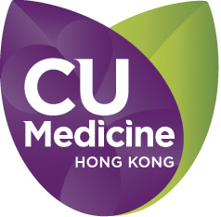

End-of-Life Care Workshops
27 Sept to 25 Oct 2018

APPLICATION FORM
(Please fill it in BLOCK CAPITALS)

PERSONAL DETAILS
Title: ❐ Prof. ❐ Dr. ❐ Mr. ❐ Ms. ❐ Miss
Surname: | Given name:
Institution /Unit : | Occupation:
Department / Ward :
Mailing Address:
 | Email:
Telephone: | Fax:

PAYMENT
Total course fees: HK$1,500
Name of Bank: | Cheque no.:
** Please write a crossed cheque addressed to “The Chinese University of Hong Kong”

TERMS & CONDITIONS
Once the payment is processed, NO cancellation can be made. Total course fees are non-refundable.

I hereby agree with the terms & conditions above.

Signature: Date:

Please return the completed Form with Payment to
Ms. Matina Yu/Kathy
9th Floor, Lui Che Woo Clinical Sciences Building c/o Dept. of Medicine & Therapeutics,
Prince of Wales Hospital, Shatin, New Territories, Hong Kong
Tel: 9168 7005
Email : b135095@cuhk.edu.hk
Updated on 31 Jan 2018

